**React**

**Day 11th**

Now we will be installing our react using vite so for the installation of react you need to run the following command.

`npm create vite@latest`

After running the command you need to specify the name for your project.

After giving name to your project you need to select library or framework we will be selecting **react.**

After selecting library we need to select language so we will be selecting **JavaScript.**

Now you’ll be getting some command you need to switch to your project folder using command `**cd projectname**`.

After switching to the specified folder you need to run one more command as `**npm install**` it will be installing bode modules which will be containing all configurations for your code.

Congrats 🎉 you’ve successfully installed react using vite.

The firs thing you need to do is you need to remove the src folder from the root directory and again create a folder with the same name src in that you need to create a file named `**main.jsx**` which is connected to your html file. In the main file you need to import react and react dom to run your react file as your react needs react library and reactdom library.

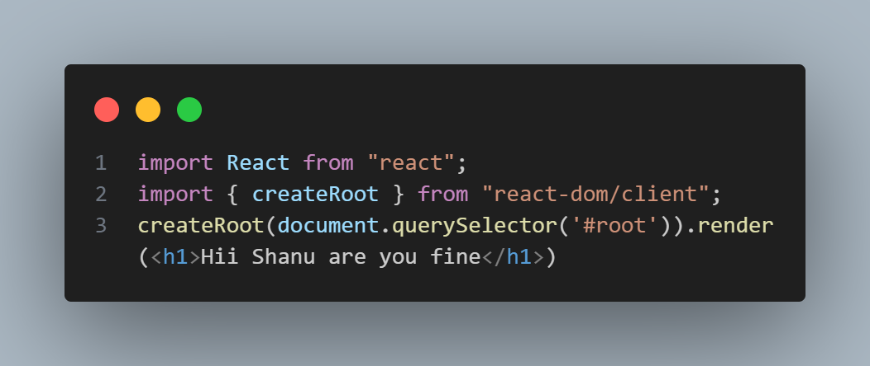There are two ways of using ReactDOM as follows.

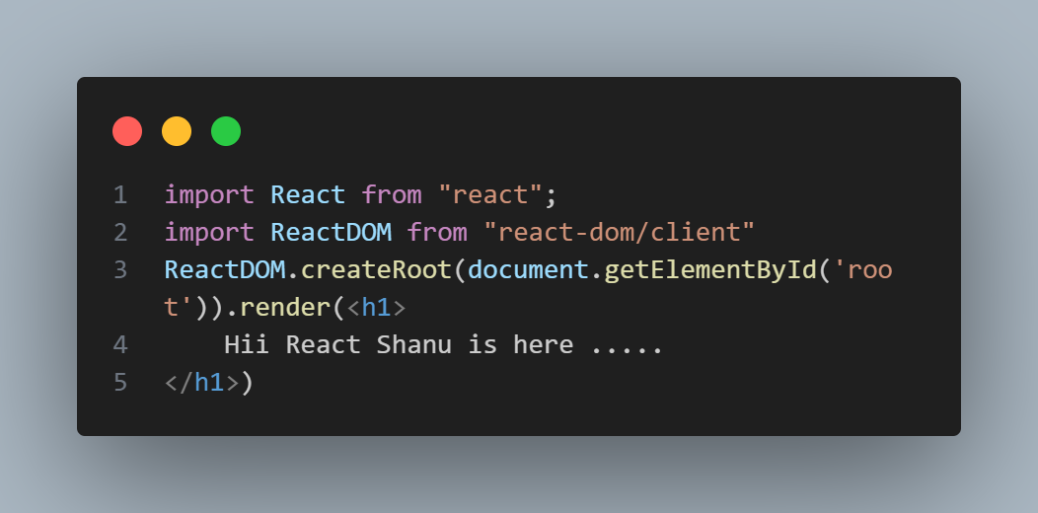

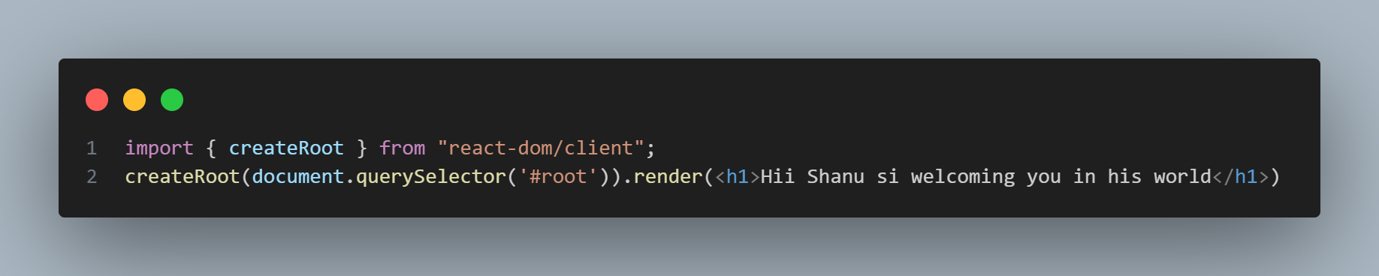**Now we’ll be doing the same with createApp**

We have already done with the installation of `create-react-app` so just remove the src folder here and again create a new folder with the same name and a separate file inside src with the name `index.js` and paste the code as shown above.